

**EE 463**

***HARDWARE PROJECT***

**AC to DC MOTOR DRIVE**

**Mehmet Eralp KÖSE 2031094**

**Mahmut Enes KARA 2030898**

**Course Instructor: Ozan KEYSAN**

**Course Assistant: İlker ŞAHİN**

**Table of Contents**

INTRODUCTION 3

COMPARISON OF THE TOPOLOGIES 4

THEORY OF OPERATION 5

Theory of Main Circuitry 5

Theory of Gate Driver 5

COMPONENT SELECTION 7

3 Phase Diode Rectifier 7

Rectifier Side Capacitance 7

Buck Side MOSFET 7

Buck Side Freewheeling Diode 8

Buck Side Capacitance 8

Buck Side Inductance 8

Loss Calculations 8

Conduction Losses 8

Switching Losses 9

SIMULATION RESULTS 12

Simulations for R Load 12

Simulations for Motor as a Load 18

TEST RESULTS 26

R Load Tests 26

Motor Tests Results 33

CONCLUSION 41

REFERENCES 42

# INTRODUCTION

In this report, detailed information about Hardware Project of METU EE 463 Course which is mainly driving a DC motor which can be seen on Figure 1, from AC power supply is presented. Main phenomena behind the project is that implementing a controllable rectifier which takes input as 3 phase AC or 1 phase AC and converting it to controllable DC. Then this controllable DC is required to drive DC motor as a load by adjusting its speed.

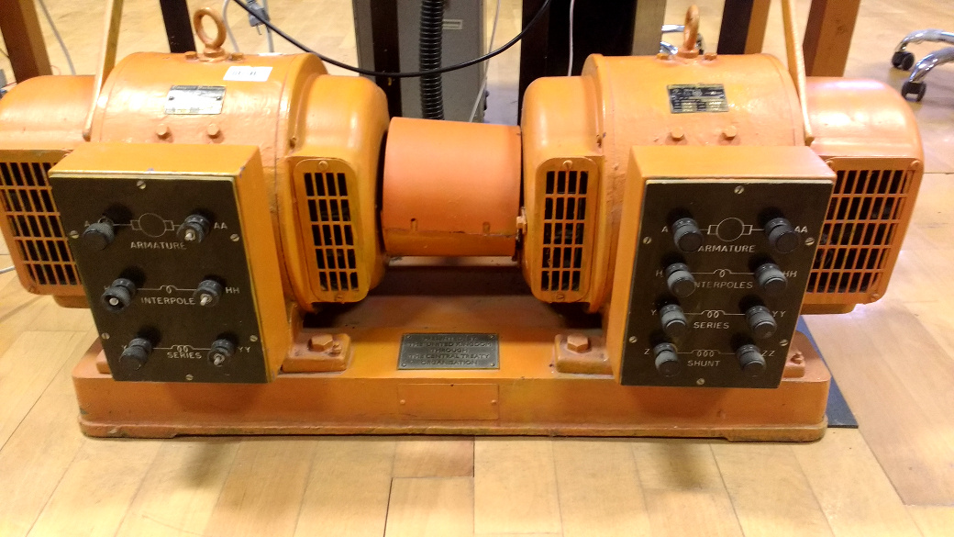Figure 1: DC Motor setup coupled with generator

Project is implemented step by step in order to achieve a successful operation of the driver. Firstly, comparison between rectifiers which are 3 phase thyristor, 1 phase thyristor and 3 phase diode + Buck converter rectifiers are discussed in terms of difficulties, cost and time consumption. So, best option is selected according to our considerations. Then project is simulated in digital environment and performances of the theoretical results are observed. Required equipment and their essential power, voltage, current etc. ratings are calculated and listed. Values of passive circuit components such as capacitors and inductors are obtained from computer simulations. Finally, setup circuitry is constructed with decided components and some test results are obtained while feeding a R load only. Then setup is connected to DC motor and performance of the setup is tested.

# COMPARISON OF THE TOPOLOGIES

As a first step of the project, most advantageous topology is selected according to ease of implementation, ease of gate drive circuitry for required topology and cost.

1 phase thyristor rectifier has high output voltage ripple and it probably requires large passive elements as a filter compared to 3 phase rectifiers. Also, it consists of 2 pair of thyristor while 3 phase rectifier consists of 3 pair of thyristor. So, this topology can be upgraded by just one pair of thyristor, in other words performance of the 3 phase rectifier is much better than 1 phase thyristor rectifier in terms of cost. Therefore this topology was not selected.

3 phase thyristor rectifier can be considered as simple in terms of required circuit components. It just requires a 3 pair thyristor module as a main circuitry. But the important thing about 3 phase thyristor rectifier is complexity of the gate driver circuitry. This circuitry is supposed to be create 6 specific synchronized pulse in one period in order to trigger thyristor gate pins separately. As this phenomena requires many synchronization transformer and complex control circuitry, its cost is very high and implementation of it very difficult and time consuming. Therefore this topology was not selected.

3 phase diode rectifier is accessible in the market compared to other topologies and its operation is very basic. But the project requires controllable DC output and this requirement can not achieved by just a rectifier module. A buck converter should be used in order to make output voltage controllable. A buck converter should be contain at least a switching element such as Mosfet and IGBT, and a freewheeling diode. Gate driver circuitry is required for gate of the switching element but it can be considered as very simple compared to thyristor gate driver circuitries as it does not require any synchronization transformer and complex control circuitry. A simple PWM producer with a potentiometer can be used with amplification circuitry of the gate driver. Therefore, the topology for the project is selected as 3 phase diode rectifier and a cascaded buck converter. In order to produce a PWM signal with variable duty cycle, an Arduino microcontroller is going to be used with a potentiometer. In order to isolate Ardunio from main circuitry and provide required current for gate of the switching element, an optocoupler which name is TLP 250 is going to be used.

# THEORY OF OPERATION

## Theory of Main Circuitry

Overall circuit diagram can be constructed as Figure 2 for selected topology, diode rectifier and buck converter. 3 phase diode rectifier takes input from 3 phase AC source and converts to 6 pulse DC waveform whose mean value is 1.35*Vs where Vs is line to line voltage of the source. In order to make output voltage of the diode rectifier smoother a filter capacitor is going to be used. Therefore, it is expected to obtain ripple free, pure DC voltage. A MOSFET and a freewheeling diode takes DC input from the rectifier and provide variable DC output whose value is D*VD where D is duty cycle applied to gate of the MOSFET and VD is output of the rectifier. An LC filter takes output of the buck converter and smooths current and voltage of the load. Note that DC motor can be considered as an RL load, therefore it also draws approximately DC current without filter but voltage of the DC motor shuttle between zero, MOSFET is off, and high DC value, MOSFET is on, at the switching frequency of the gate driver. So, motor may be influenced from this situation in a long time. Therefore, using a filter capacitor is decided but it also requires a filter inductance because two filter capacitors should not be shorted at any time i.e. when MOSFET is on, current drawn from first capacitor should be limited.

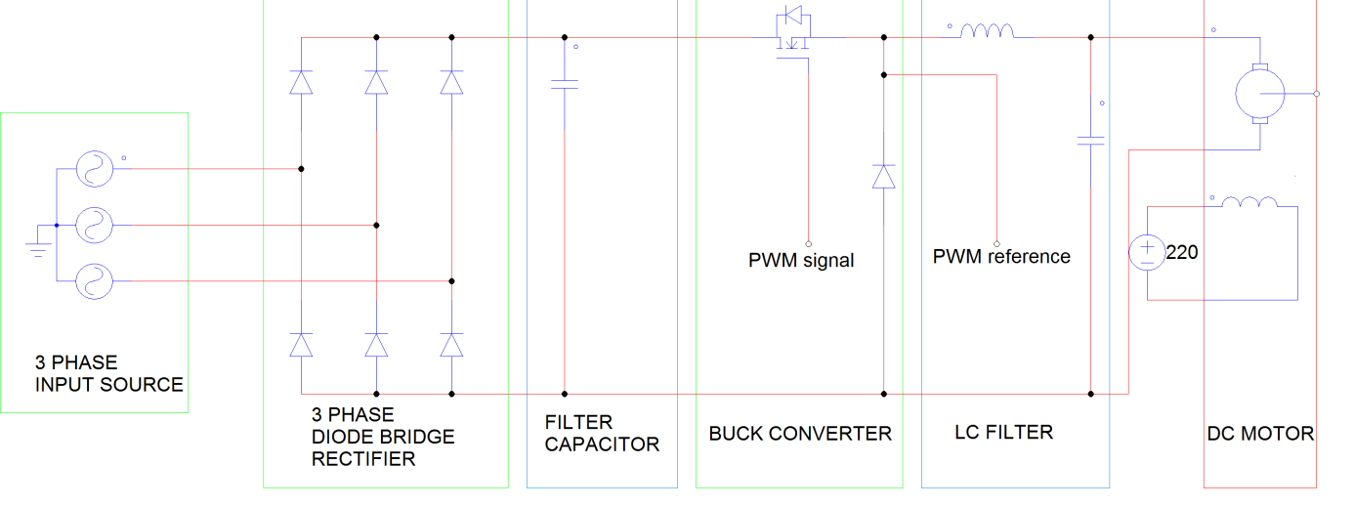Figure 2: Overall Circuitry

## Theory of Gate Driver

Ideally MOSFETs don’t require any feeding current for opening from their gate pin. But practically gate to source capacitance of them should be charged while opening the MOSFET and should be uncharged while closing the MOSFET. This problem can be solved easily in small application because charging and discharging this capacitance just requires currents about ten mA range. But in power MOSFET this problem should be tackled by carefully. PWM signal should be amplified before connected to gate of MOSFET. Also isolation of this circuitry should be provided for safe operation.

In order to provide both isolation and amplification, gate driver modules are investigated and it is pointed out that TLP 250 [1] can supply both isolation and amplification of the signal. As seen from Figure 3, TLP 250 is an optocoupler module which turns on the inside led according to its input. By the help of the photosensor on the other side of the module lighting of led is captured. So isolation is provided. In order to drive led of the module Arduino’s PWM output is sufficient because it requires 11 mA and Arduino’s PWM output can supply up to 30 mA.

In order to provide amplification, TLP 250 has amplifier circuitry after photosensor as seen from Figure 3. Therefore output of the module can be connected to MOSFET gate with a small resistance value in order to prevent instantaneous high current drawing. On the other hand VCC and GND of the module which are 8th and 5th pins respectively should be supplied from a floating DC source because it GND pin should be connected to MOSFET source pin. TLP 250 requires at least 15 V for its DC supply pins. Therefore two 9 V cell batteries may be connected as DC supply. Also a bypass capacitor which is 0.1µF and a protection resistor, 12 kΩ, is added to circuitry.

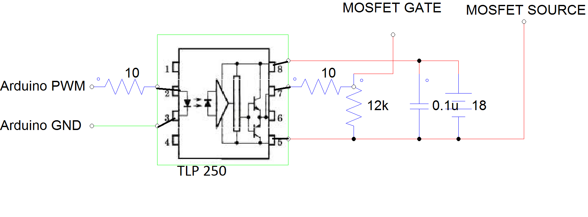Figure 3: Gate Driver Circuitry

# COMPONENT SELECTION

## 3 Phase Diode Rectifier

Requirements: At least 15 A continuous current as DC motor takes very high current at startup. Maximum RMS voltage should be larger than 200 V and maximum recurrent peak reverse voltage should be larger than 500 V

Selecter Rectifier Module: SKBPC3516 [2]

Maximum Average Forward Rectified Current: 35 A

Maximum RMS Voltage: 1120 V

Maximum Recurrent Peak Reverse Voltage: 1600 V

Note that ratings are very above the limits of the requirements because there is no big cost. differences for smaller ratings.

## Rectifier Side Capacitance

Requirements: At least 300 V voltage rating.

Selected Capacitor:

Voltage Rating: 450 V

Capacitance Value: 480 µF

## Buck Side MOSFET

Requirements: At least 15 A continuous current. At least 300 V DC Drain to Source voltage as dc link capacitor voltage on the rectifier side is going to be rise to 220 V. Gate to source voltage should be greater than 18 V as optocoupler is fed from 18 V battery cell. On and off time should be small.

Selected MOSFET: IRFP460 [3]

Continuous drain current: 20 A

Drain to Source Voltage: 500 V

Gate to Source Voltage: 20 V

Gate Threshold Voltage: 4 V(max)

Rise Time: 120 ns(max)

Fall Time: 98 ns(max)

## Buck Side Freewheeling Diode

Requirements: At least 15 A continuous current. Blocking voltage should be greater than 300 V. Reverse recovery time should be minimal.

Selected Diode: DSEP30-06A [4]

Continuous Current: 30 A

Repetitive Reverse Blocking Voltage: 600 V

## Buck Side Capacitance

Requirements: At least 300 V voltage rating

Selected Capacitor:

Voltage rating: 400 V

Capacitance Value: 680 µF

## Buck Side Inductance

Selected Inductor: Inductor is constructed by winding a cable around a ferrite toroid core

Inductor Value: 2.8 mH

# Loss Calculations

## Conduction Losses

Conduction Losses are going to be calculated for no load values i.e. load current is about 2 A.

3 phase diode rectifier: Maximum forward voltage is about 1.2 V and two of them are on at the same time. Therefore PRECT=2*1.2*2=4.8 W.

MOSFET: Drain to Source on resistance is 0.27 Ω. Therefore PMOS= I2*rON= 22*0.27= 1.08 W. Note that conduction loss of the MOSFET increases dramatically by increasing load current. For full load, load current is about 10 A, conduction loss is about 27 W. Conduction losses are calculated for maximum duty cycle.

Diode: Threshold voltage= 0.91 V and slope resistance is 8.7mΩ. Forward voltage drop for 2 A is about 0.93 V. So PDiode= V*I=0.93*2=1.86 W. For full load, voltage drop is about 1 V. So, conduction loss is about 10 W. Conduction losses are calculated for maximum duty cycle.

## Switching Losses

3 phase diode rectifier: Switching losses occurs with very low frequency. It can be ignored with no doubt.

Freewheeling Diode: The same as 3 three phase diode rectifier, frequency is very low and it can be ignored with no doubt.

Mosfet:

Switching losses are related to gate charge and switching frequency. When switching frequency is increased, switching losses are increased. Switch ON state energy and switch OF state energy are two crucial points in order to calculate switching frequency.

Switch ON state energy is shown in Eq. (1).

Switch OFF state energy is shown in Eq. (2).

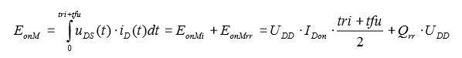

Eq. (1)

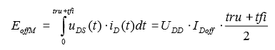

Eq. (2)

Where, IDon=20 A for 25 0C

IDoff = 1.3 A for 25 0C

(tri+tfu)/2 is nearly equal to voltage fall time = 65 ns

(tru+tfi)/2 is nearly equal to voltage rise time = 81 ns

UDD =1.8 V

Qrr = 18 uC

EonM = 3.5*10-5

EoffM = 1.9*10-7

Eq. (3)

Switching loss is nearly 0.14 W at 25 0C with 3.9 kHz switching frequency from Eq. (3).

If load current is nearly 10 A, conduction loss is nearly 27 W, as stated previously and switching loss is nearly 0.14 W so total loss is nearly 27.14 W. Junction to ambient thermal constant is 30 0C/W for IRFP 460 so junction to ambient temperature difference is 30*27.14= 814 0C. Therefore, heat sink should be used.

# SIMULATION RESULTS

There are two different simulations for R load and RL load; that is, motor. Initially, simulations are observed for R load because practically R load tests are tried before motor tests. In the laboratory, R loads are durable for 3 A so Input peak voltage is 80 V line to line and output current is nearly 3 A at the simulations. Also, duty cycle is 0.7. Also, R is 17.7Ω because in the laboratory, each resistors are 50 Ω and maximum current can be obtained if each load are tied parallel.

## Simulations for R Load

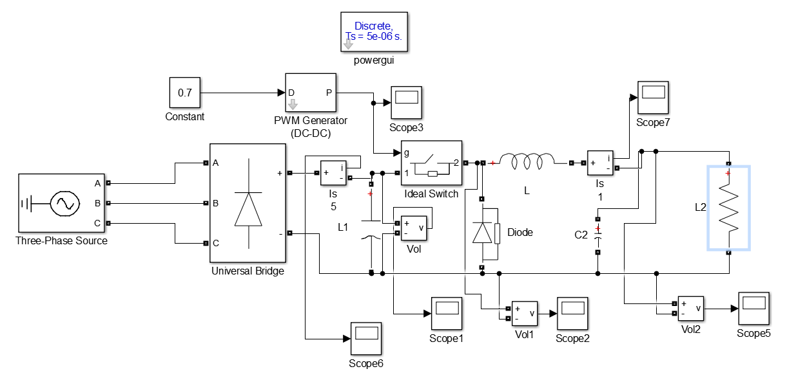

Figure 4: Circuit Schematic with R Load (Without Gate Driver)

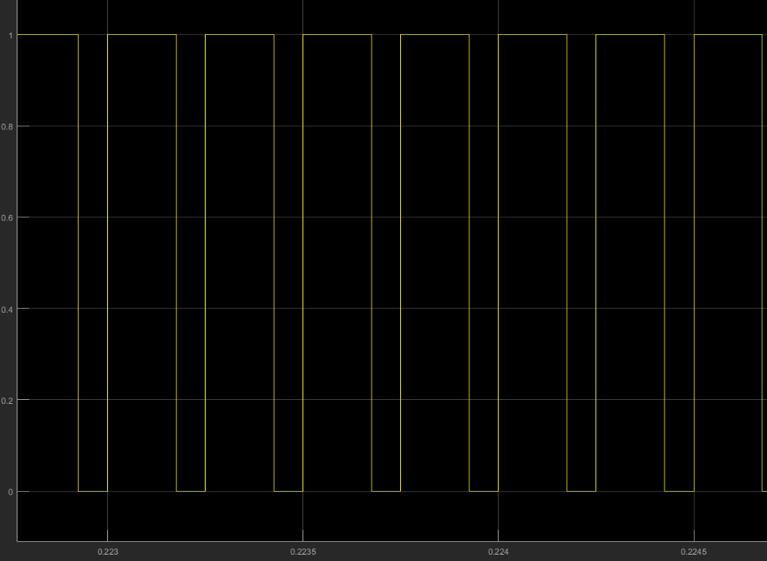

Figure 5: Duty Cycle is 0.7

Duty cycle is 0.7 for all simulation results.

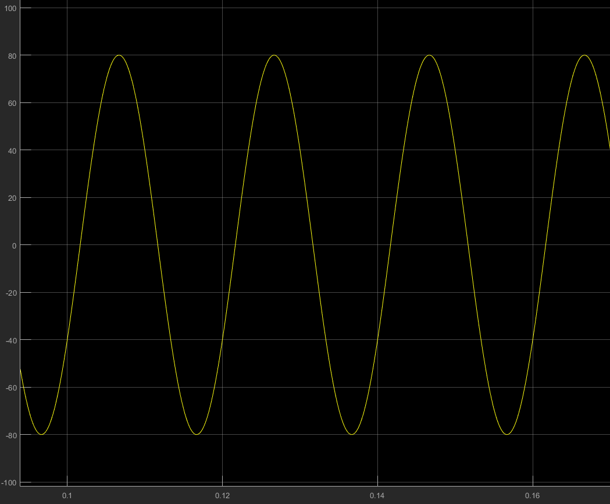

Figure 6: Input Voltage for R load

Input line to line voltage is 80 Vpeak at the simulations for R load.

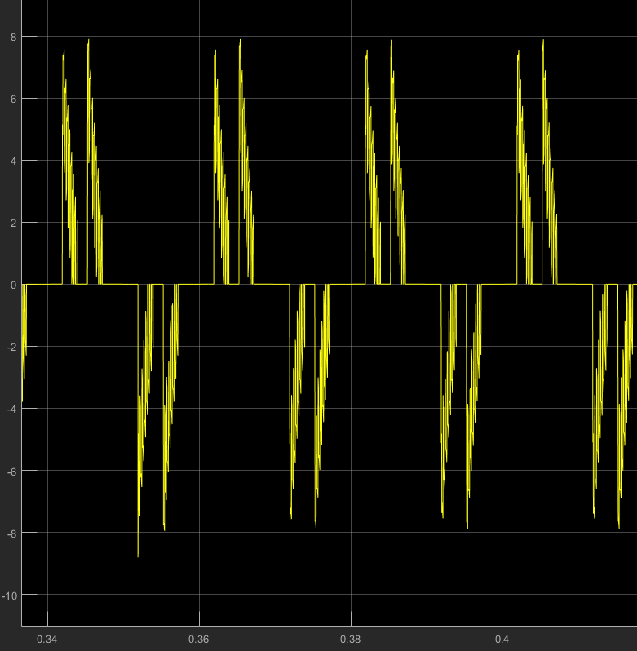

Figure 7: Input Current for R load

There is a capacitor for filtering after three phase diode rectifier. Therefore capacitor try to charge and input current is observed as Figure 7. If there were not a capacitor, third harmonics would disappear and waveform would be similar to sinusoid wave except third harmonics.

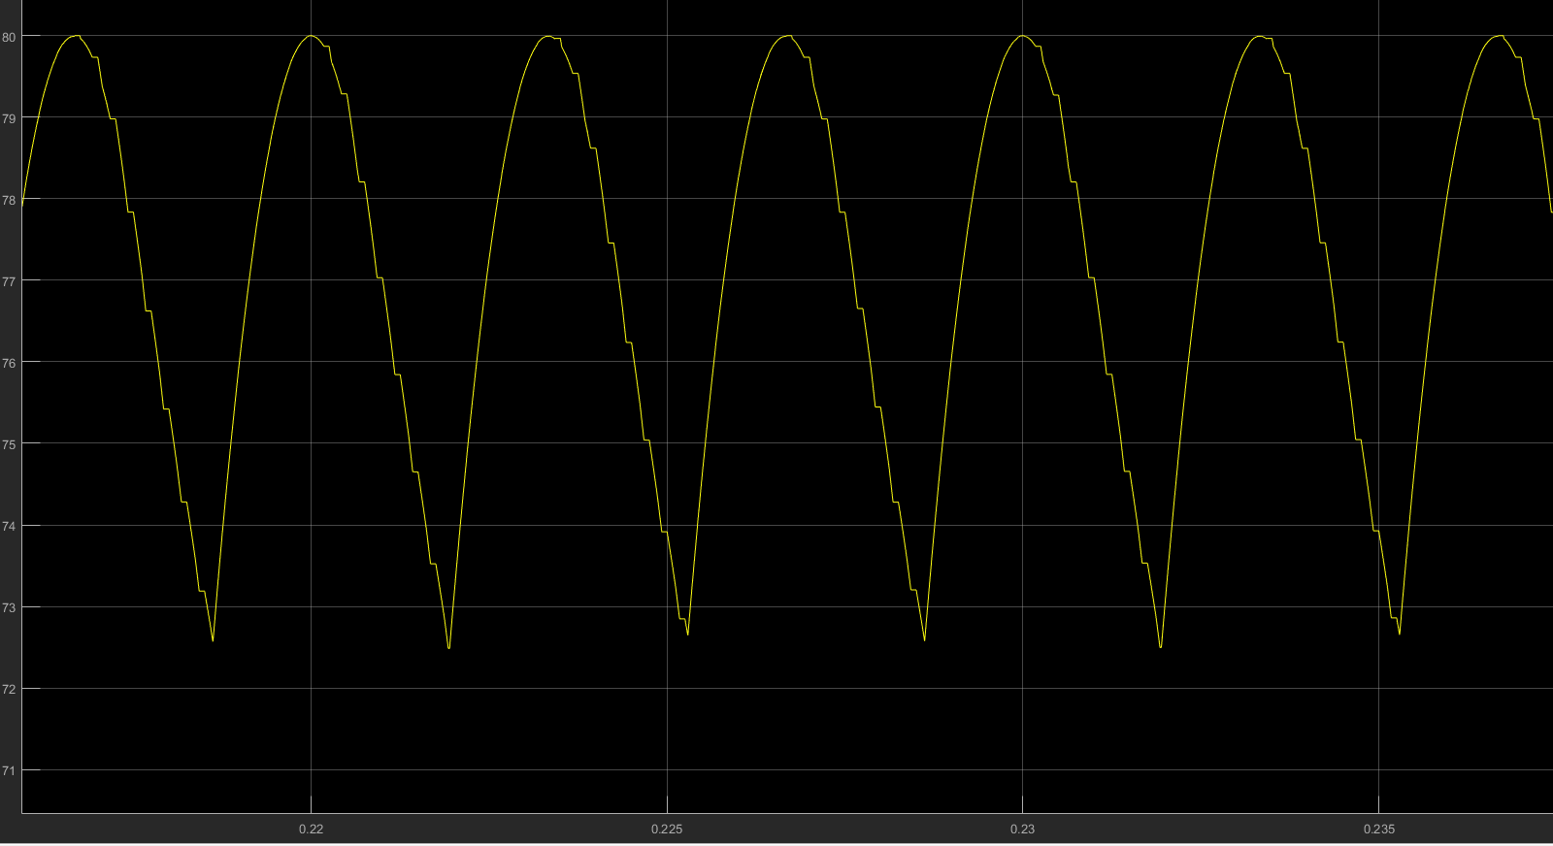

Figure 8: Output of Three Phase Diode Rectifier with 470 uF Capacitor Filter

There is output voltage of three phase diode rectifier at Figure 8. Output voltage have 6 pulse waveform and the frequency is 300 Hz. Also, output ripple is between 73 and 80 V so ripple is 7 V. If there were not a capacitor for filtering, output ripple of three phase diode rectifier would be 11 V.

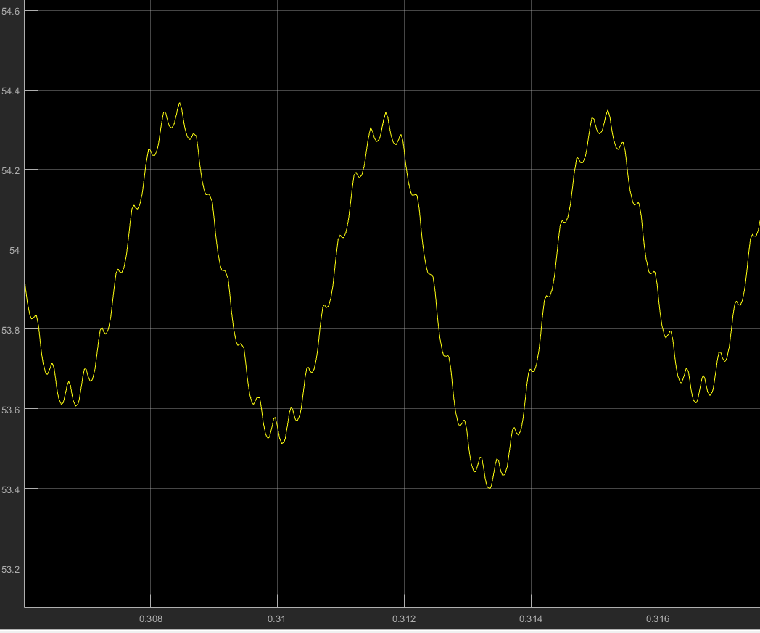

Figure 9: Output Voltage for R Load

After the output of the three phase diode rectifier, buck converter is used and output voltage ripple is observed as Figure 9 from the simulation. At the buck converter side 680 uF capacitor and 2.8 mH inductor are used and ripple is nearly 1 V. If capacitor value is increased, the ripple will decrease.

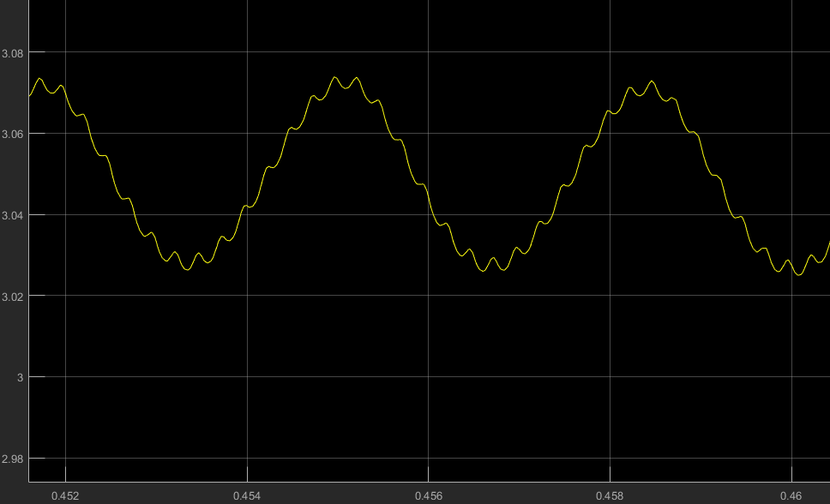

Figure 10: Output Current for R Load

There is an R load so Output current and output voltage have similar waveform because

$$Voltage=Current*Resistor$$

Therefore, output ripple has almost DC characteristic and ripple is decreased if capacitance is increased.

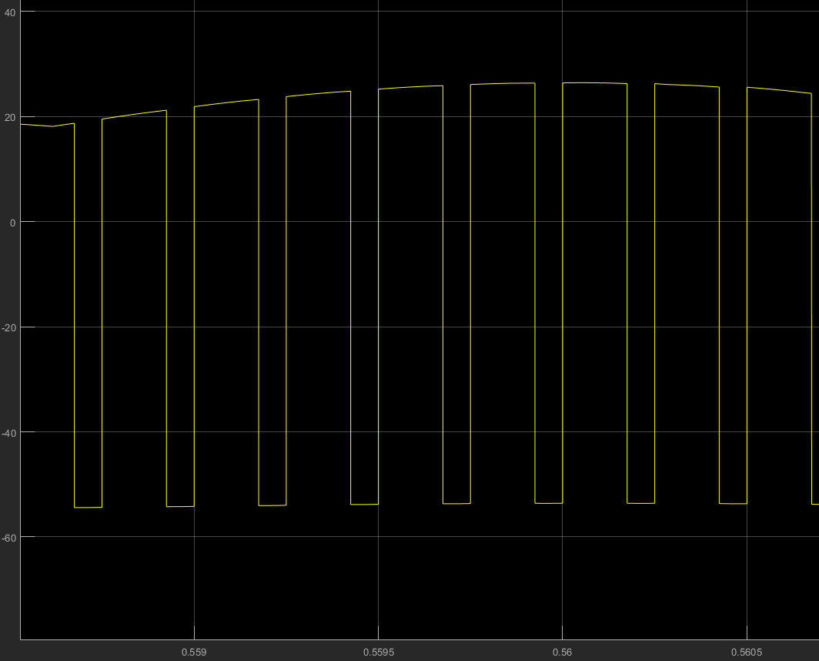

Figure 11: Inductor Voltage for R load

Inductor voltage has Vd-Vo value for switch ON state and it has –Vo value for switch OFF state. Also, continuous conduction mode is observed from the simulation for 3.9 kHz switching frequency.

## Simulations for Motor as a Load

Secondly, Simulations are done for motor load. To do this, motors parameters are determined as

* Armature Winding: 28 Ω, 13.3 mH
* Series Winding: 65 mΩ, 260 uH
* Shunt Winding: 8.26 kΩ, 6.4 H
* [Interpoles](https://www.quora.com/Electrical-Machines-What-do-interpoles-do-in-DC-motors) Winding: 0.8 Ω, 5.8 mH

Duty cycle is again 0.7 and output voltage is nearly 220 V at this part. Threfore input line to line voltage is nearly 320Vpeak.

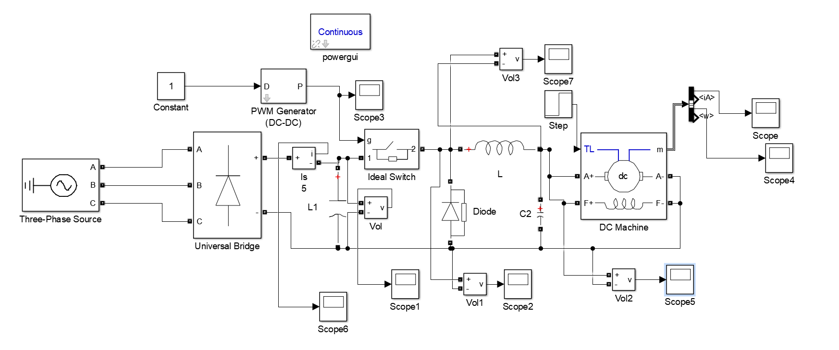

Figure 12: Circuit Schematic with DC Motor (Without Gate Driver)

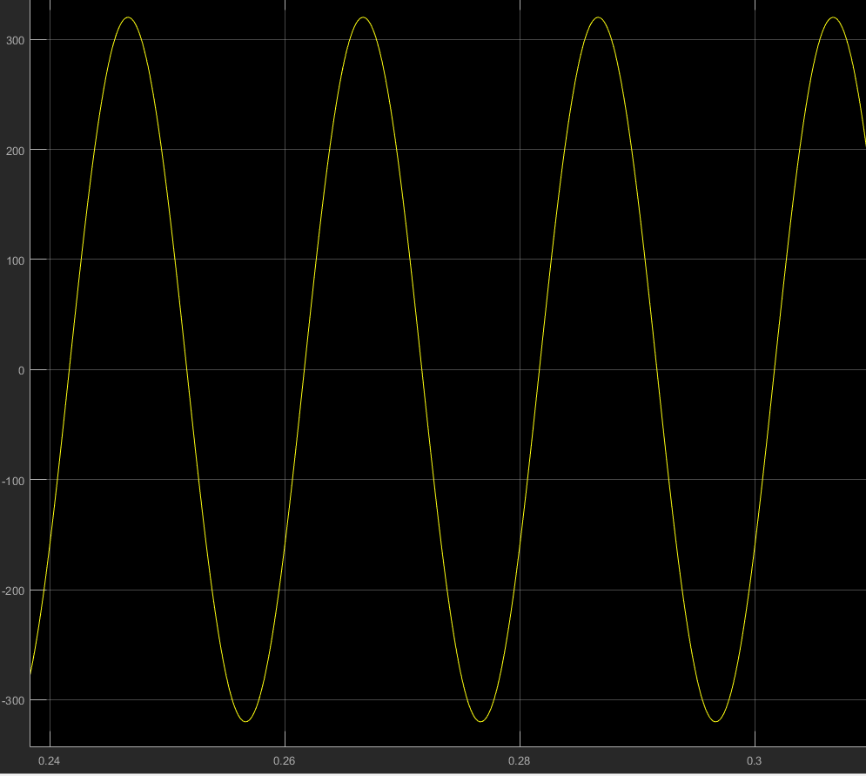

Figure 13: Input Voltage Waveform for 320 Vpeak line to line

Input line to line voltage is 320 Vpeak as shown in Figure 13.

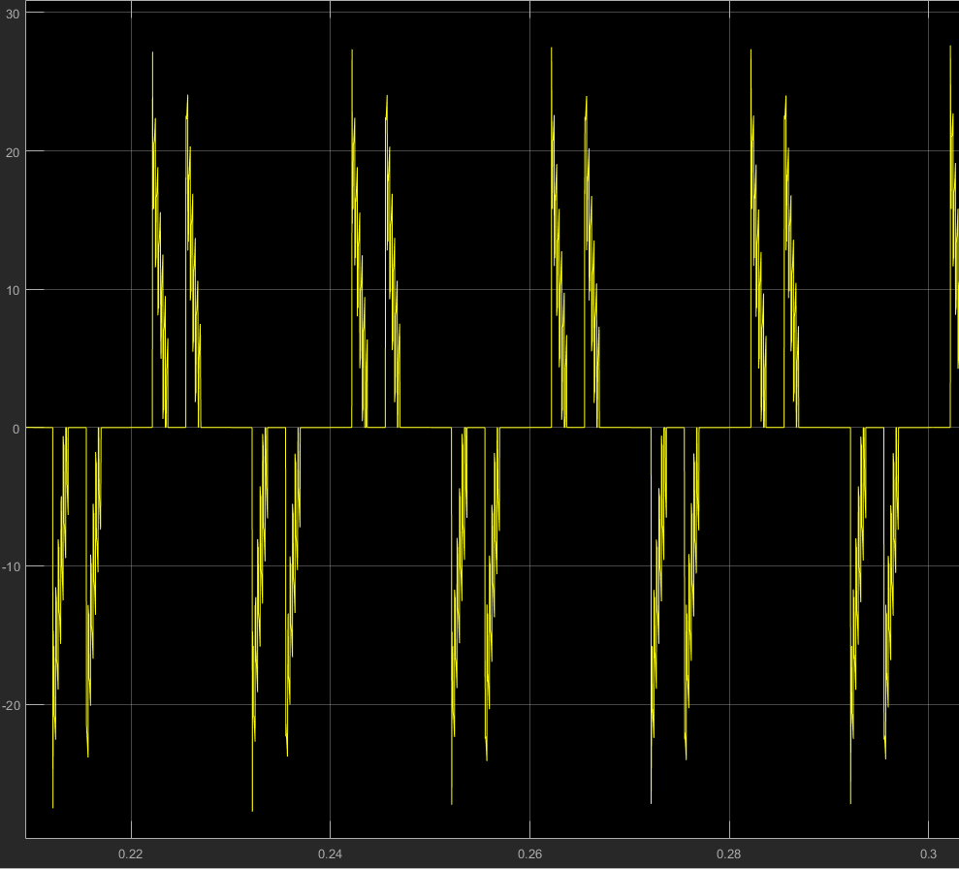

Figure 14: Input Current Waveform for 320 Vpeak line to line

Similar to R load, there is a capacitor after three phase diode rectifier and it try to charge and input current has a characteristic as shown in Figure 14.

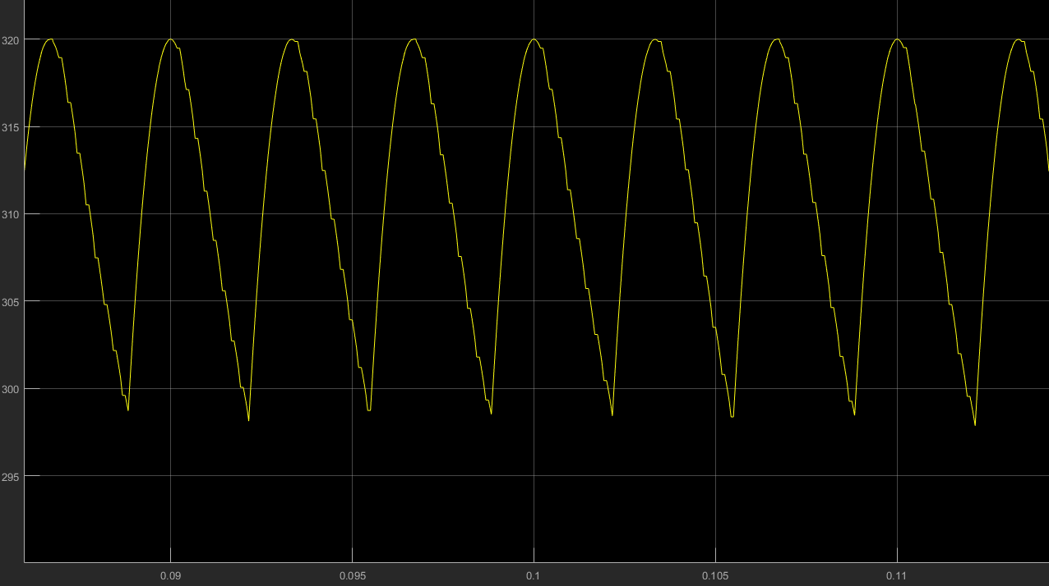

Figure 15: Output Voltage of 3 Phase Rectifier After 470 uF Capacitor Filter

As shown in Figure 15, output voltage of the three phase rectifier has six pulse characteristic and 300 Hz frequency is observed. Output ripple is nearly 20 V for 320 V peak voltage; that is ripple is nearly 6.25%. If there was not a capacitor after three phase diode rectifier, output ripple would be nearly 43 V; that is 13.45%.

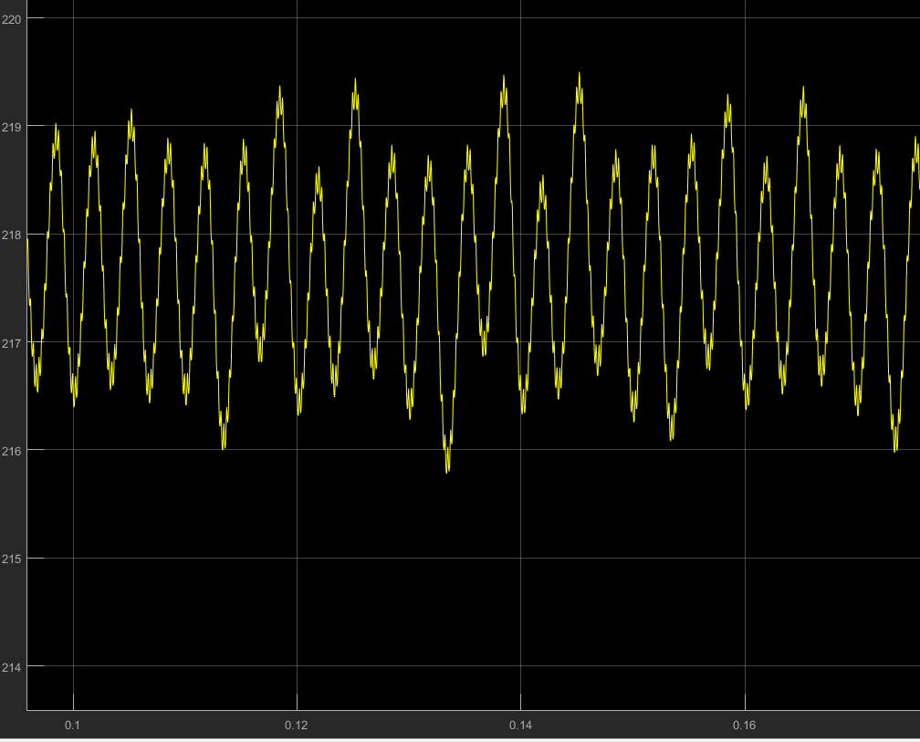

Figure 16: Output Voltage when D=0.7 and input voltage 320 Vline

There is output voltage waveform for motor load in Figure 16. There is buck converter after three phase rectifier and thanks to LC filter at the buck converter side, output voltage ripple is very low, which is nearly 1.4%. There is some spikes, however, it does not affect the motor considerably.

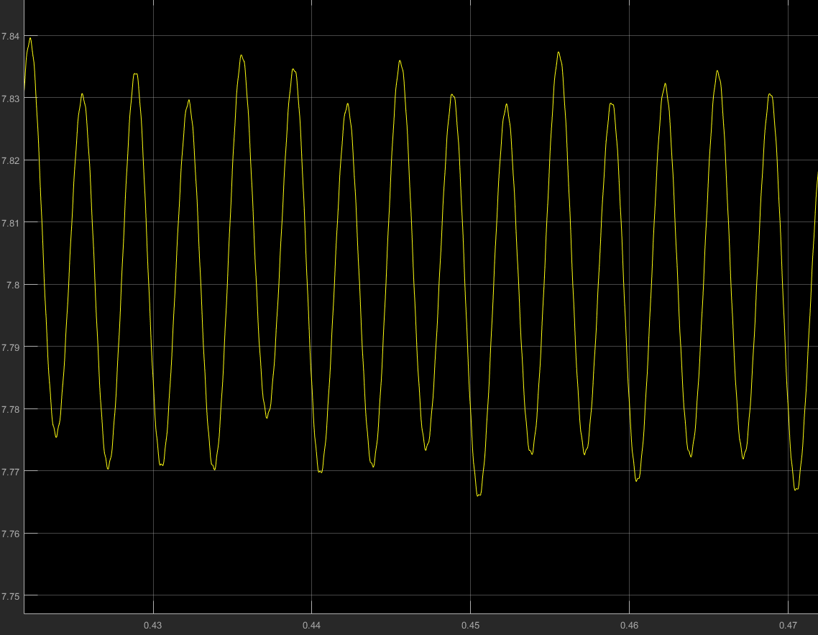

Figure 17: Output current when D=0.7 and input voltage 320 Vline

Armature resistance is given as 28Ω for the motor so output current should be 1/28 of the voltage characteristic. In other words, waveform characteristic of output voltage is similar to that of output current; however magnitudes are different of course. Ripple is low which is nearly 1.3%.

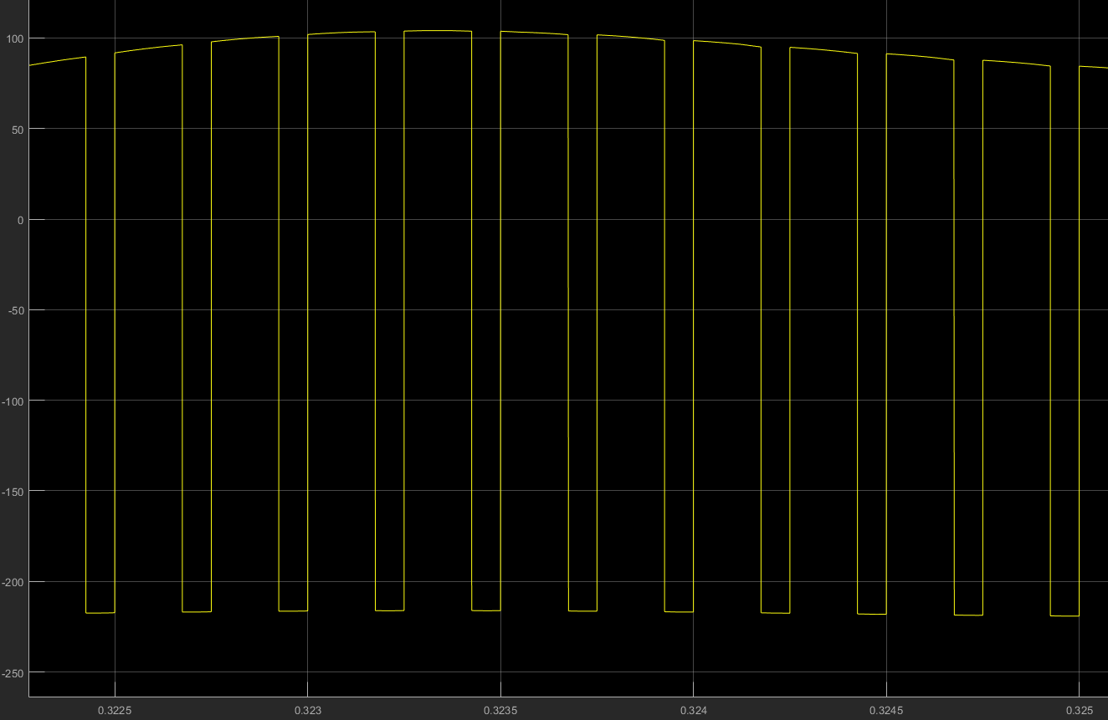

Figure 18: Inductor voltage when D=0.7 and input voltage 320 V (line to line)

There is inductor voltage waveform at Figure 18. Continuous conduction mode is observed at the simulation. If switching frequency is decreased, discontinuous conduction mode can be observed because

$IL,boundary=\left(1-D\right)*D*Ts*\frac{Vd}{2*L}$ (4)

# TEST RESULTS

In this project, DC motor is driven; however, before motor tests, R load is connected to motor driver circuit and some characteristics are observed. Also, test results and simulations are compared.

There are two experiments, the first one is motor driver circuit with R load, the other one is motor tests.

## R Load Tests

Initially, R load test are observed. In this process, three phase AC voltage is sent to three phase diode rectifier firstly. As expected six pulse waveform is observed and its frequency is 300 Hz because three phase AC voltages’ frequency is 50 Hz.

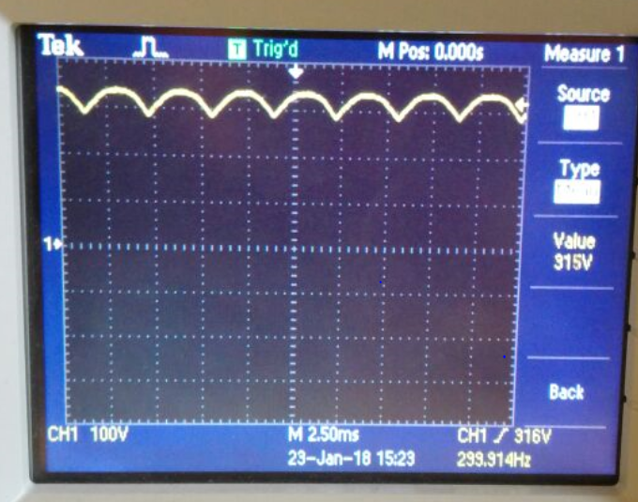

Figure 19: Output Voltage of the Three Phase Diode Rectifier

As shown in Figure 19, six pulse voltage waveform is observed at the output of the three phase diode rectifier. It also corresponds to simulation results. After three phase diode rectifier, 470 uF which has 450 V voltage rating capacitor is used and almost DC voltage is observed. If the capacitance is increased, ripple could be decreased much more but cost will increase. Also, there is another filter at the buck converter side so capacitance is not much crucial.

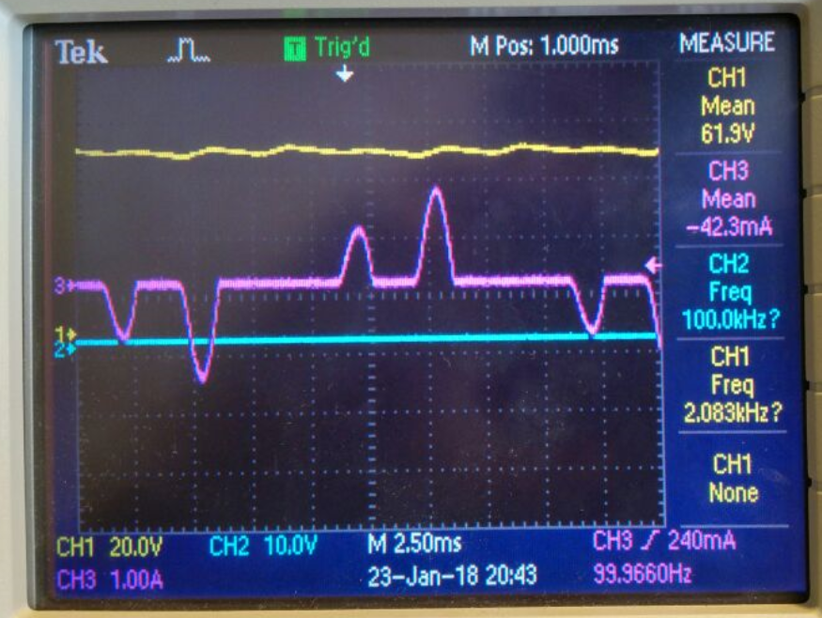

Figure 20: Input Current Waveform for R Load (Purple Line)

As stated, 470 uF capacitor is used after three phase diode rectifier so input current observed as Figure 20. Capacitor is charged and discharged so there is an oscillation at input current.

After three phase diode rectifier, buck converter is used and IRFP460 power MOSFET which has 20 A, 500 V ratings is used for switching element. Also, IXGH32N90B2 IGBT whose ratings are 50A – 600 V is tried but eventually, Power MOSFET is used. Gate driving and isolation are two crucial points at this point and TLP250 optocoupler module is preferred in order to supply isolation and gate driving.

In order to investigate output characteristics of the optocupler, the circuit seen in Figure 3 is constructed without making any connection on the MOSFET gate and source side. As a result, output voltage is observed as seen in Figure 21. A limit for duty cycle is put on Arduino code upper limit of %85, lower limit of %15. Morevoer, frequency is adjusted to 3.9 kHz. Potentiometer is rotated maximum to minimum and duty cycle for each entire region is investigated. Setup worked properly.

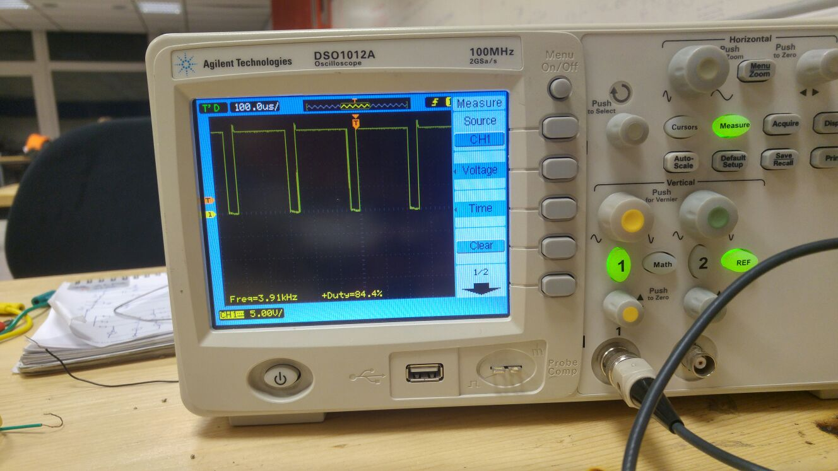

Figure 21: Output of the Optocoupler

Moreover, another test for optocoupler is conducted. As main function of the gate driver module is charging and discharging gate to source capacitance of the switching element, a 40 nF capacitor is connected to gate and source pins of the circuit seen in Figure 3 in order to point out rise and fall time. As a result, characteristics which can be seen in Figure 22 is observed. Gate to source capacitance of the MOSFET is about 4 nF, therefore it is observed that supply current of the optocoupler will be enough for driving MOSFET and transient between on to off and off to on can be done with no timing problems.

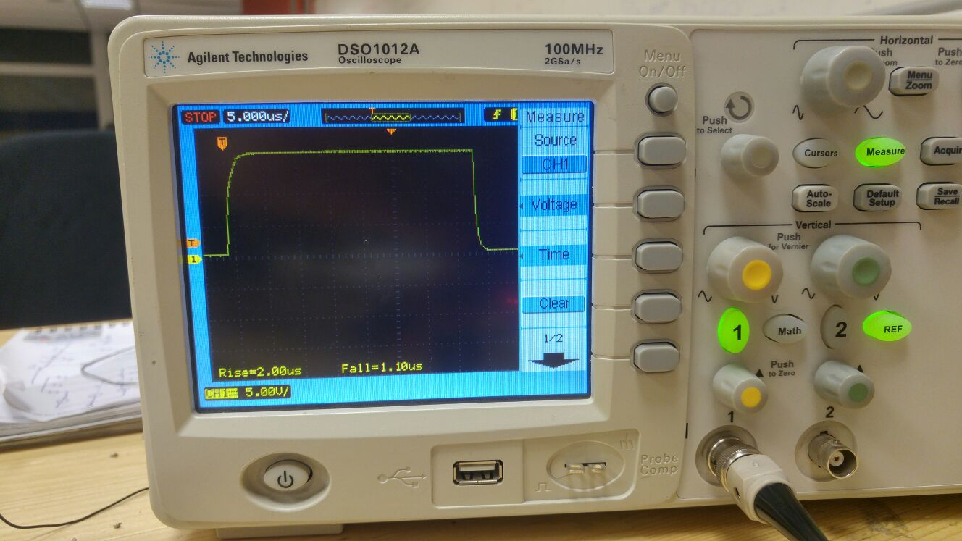

Figure 22: Rise and Fall Time of the Optocoupler Output

After this test, output of the MOSFET’s source channel is observed and its characteristic is the same as PWM which arrives to gate channel as expected. At this form motor can be driven because motor have RL characteristic and current can be supplied to motor; however another RC filter is used before motor so output voltage and current is obtained as a DC waveform as shown in Figure 23.

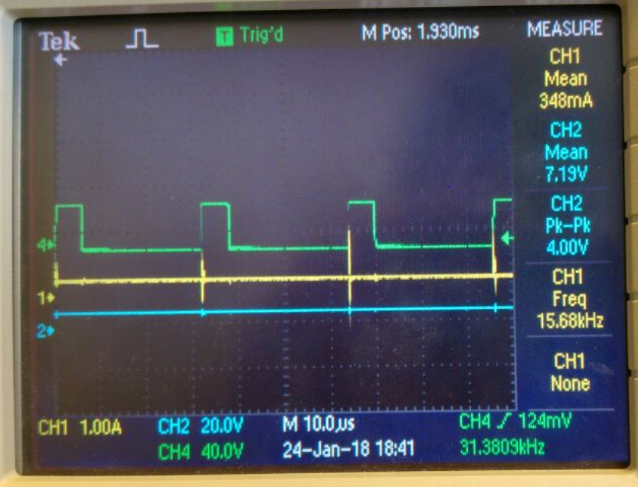

Figure 23: Output PWM of Optocoupler, Output Voltage and Output Current

As shown in Figure 23, output current (yellow line) and output current (blue line) are almost pure DC waveform. However, there are spikes at output the current at switching instants. This can be caused by discontinuous conduction mode. Therefore inductor voltage is observed whether there is a discontinuous conduction mode or not.

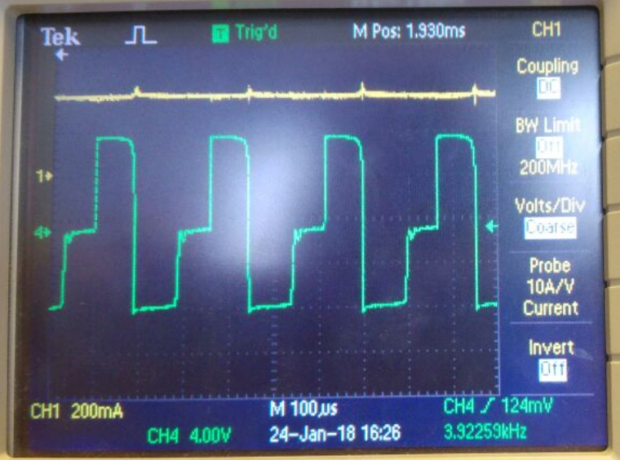

Figure 24: Inductor Voltage at R load

As shown in Figure 24, inductor current is zero sometimes. If there is continuous conduction mode, inductor voltage would be only Vd-Vo and –Vo when switch is ON and OF respectively. That is, if inductor voltage is zero at some instant, discontinuous conduction mode is observed. Therefore frequency is increased 30 kHz from 3.9 kHz.

$IL,boundary=\left(1-D\right)*D*Ts*\frac{Vd}{2*L}$ (5)

As shown Eq (5). if frequency is increased, IL,boundary will decrease and continuous conduction mode can be observed and continuous conduction mode is observed as expected however, spikes are still observed at output current. Therefore, 3.9 kHz switching frequency is used in order to decrease switching losses.

Also, THD (total harmonic distortion) is observed for R load. It indicates the distortions from fundamental harmonic for line current.

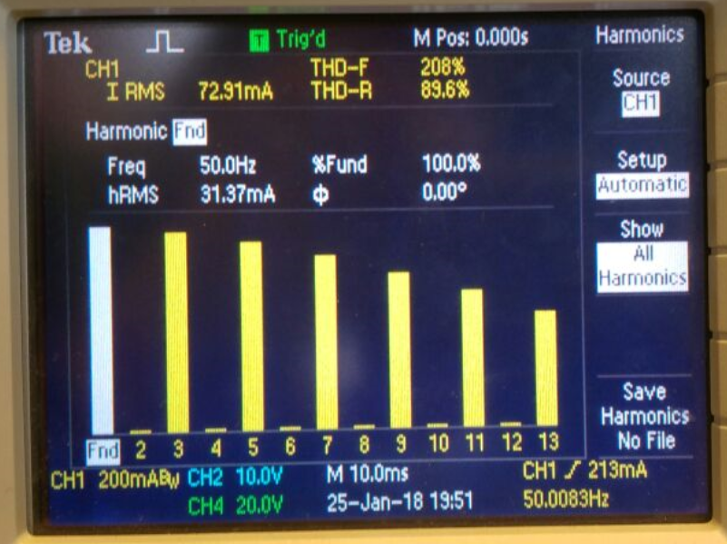

Figure 25: THD for R load

As shown in Figure 25, odd harmonics are effective and THD is very high. THD can be decreased by adding line inductances at the source side.

## Motor Tests Results

After R load test, motor is tested. Motor parameters is given as;

* Armature Winding: 28 Ω, 13.3 mH
* Series Winding: 65 mΩ, 260 uH
* Shunt Winding: 8.26 kΩ, 6.4 H
* [Interpoles](https://www.quora.com/Electrical-Machines-What-do-interpoles-do-in-DC-motors) Winding: 0.8 Ω, 5.8 mH

In this process, DC motor driver is the same; that is, three phase diode rectifier and buck converter topologies are used. Initially, AC voltage is sent to three phase diode rectifier and six pulse voltage waveform is observed and ripple is decreased via 470 uF capacitor. After that, IRFP460 power MOSFET which has 20 A, 500 V ratings is used for switching element. Theni RC filter is used and output of the filter is sent to the motor. Firstly, motor pulls a lot of current suddenly, also there is a long cable between output of optocoupler and gate channel of the power MOSFET so there is much inductance between output of optocoupler and gate channel of the MOSFET.

$Vl=L*\frac{di}{dt}$ (6)

As shown Eq (6), inductance increases, voltage oscillation of the gate channel also increases. Therefore, power MOSFET is burst at the first trial. At the second trial, IXGH32N90B2 IGBT burn. Short circuit is observed between collector and emitter channels. Finally, IRFP460 power MOSFET is used again and motor is driven successfully.

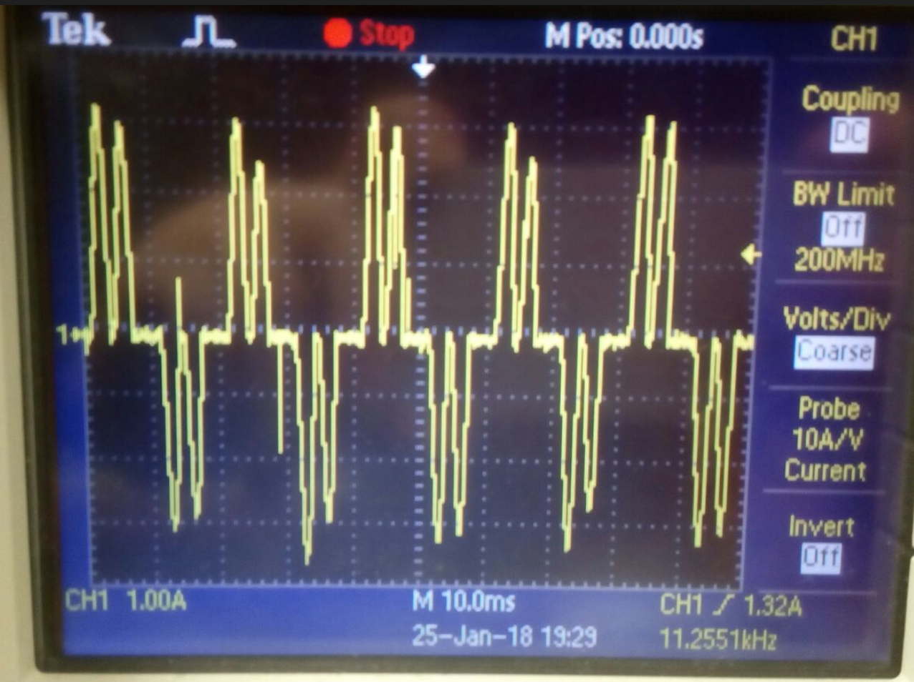

Figure 26: Input Current Waveform for Motor Load

Input current is shown as Figure 26, it correspond with simulation results. As explained R load part, third harmonic disappears and current is observed as Figure 26, due to capacitor.

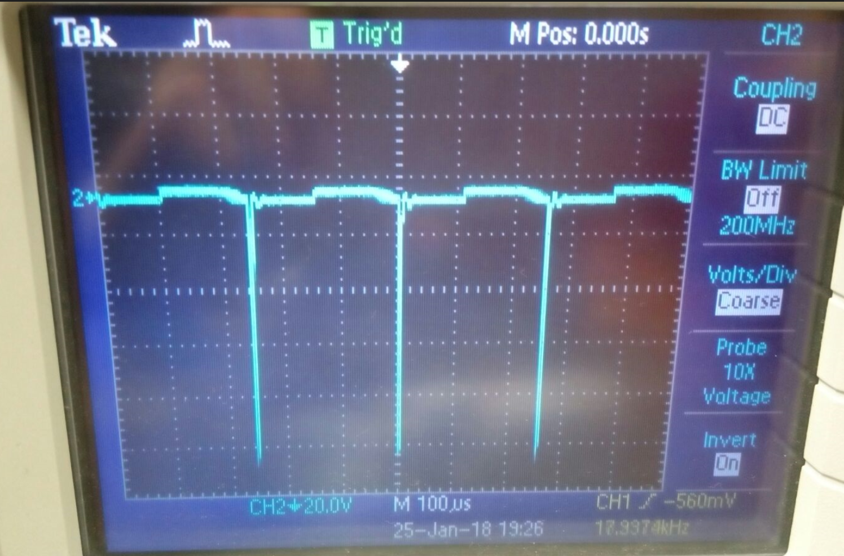

Figure 27: Inductor Voltage for Motor Load

As shown in Figure 27, Inductor voltage is zero sometimes so discontinuous conduction mode is observed as R load test. Motor speed changes less when PWM is increased or decreased due to discontinuity. As explained R load test, if frequency is increased, boundary inductor current will decrease and discontinuity can be disappeared. Therefore, motor speed can be changed much more when PWM is changed; however, switching loss will increase.

THD is also observed at motor test. Theoretically, THD should be nearly 32% for three phase rectifier with RL load.

$THD=\frac{\sqrt{\left(Irms^{2}-I1rms^{2}\right)}}{I1rms}$ (7)

Where, Irms= √(2/3) , I1rms= √6/π

However, input current is not square waveform actually and THD is high as shown in Figure 28. THD is nearly 79% at motor test.

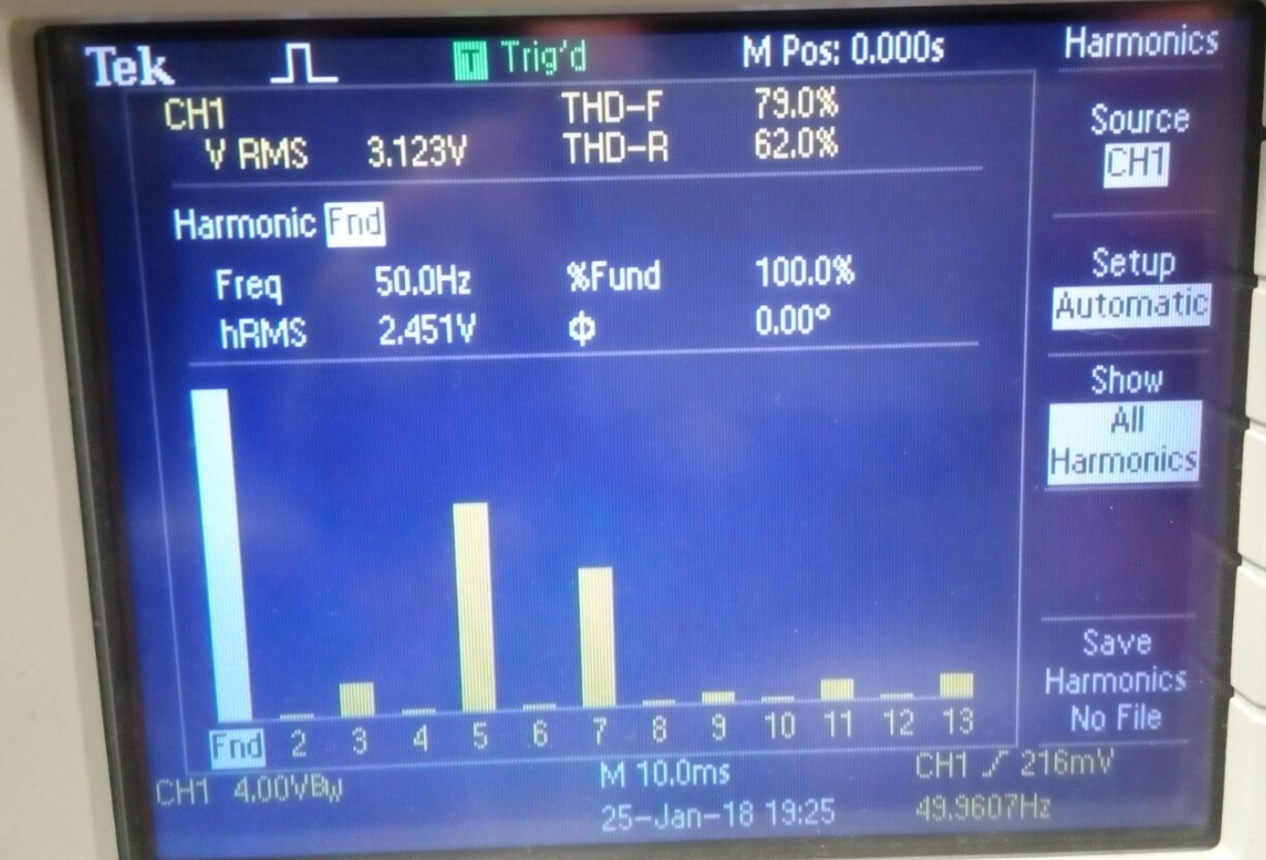

Figure 28: THD for Motor load

After three phase diode rectifier and switching power MOSFET, LC filter (L=2.8 mH and C=680 uF- 400V) is used and nearly a DC voltage and current are observed.

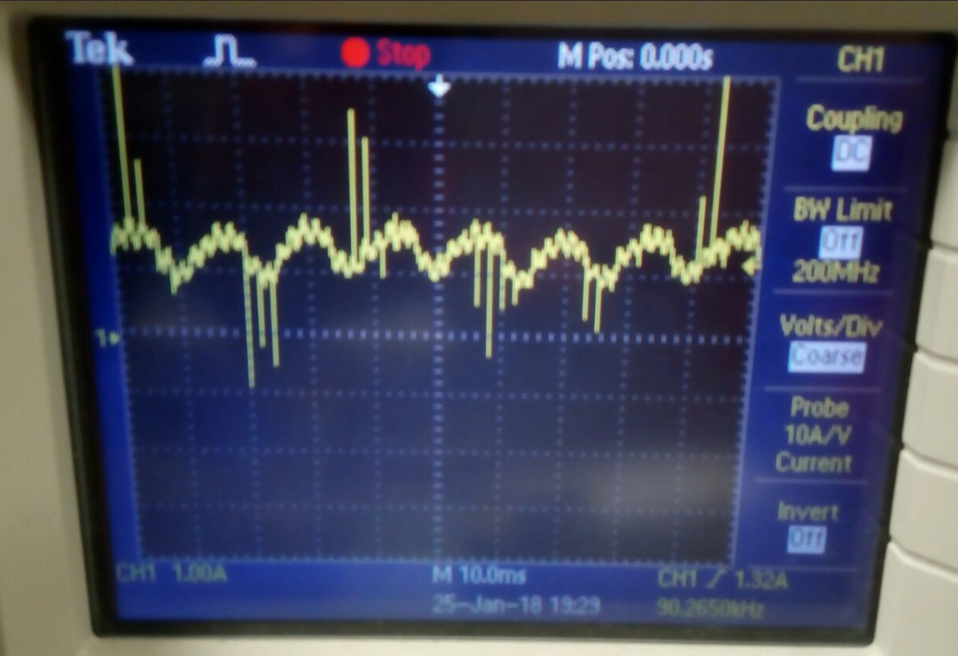

Figure 29: Output Current for Motor Load

There is output current ripple at Figure 29, nearly 1A ripple is observed for 2A peak.

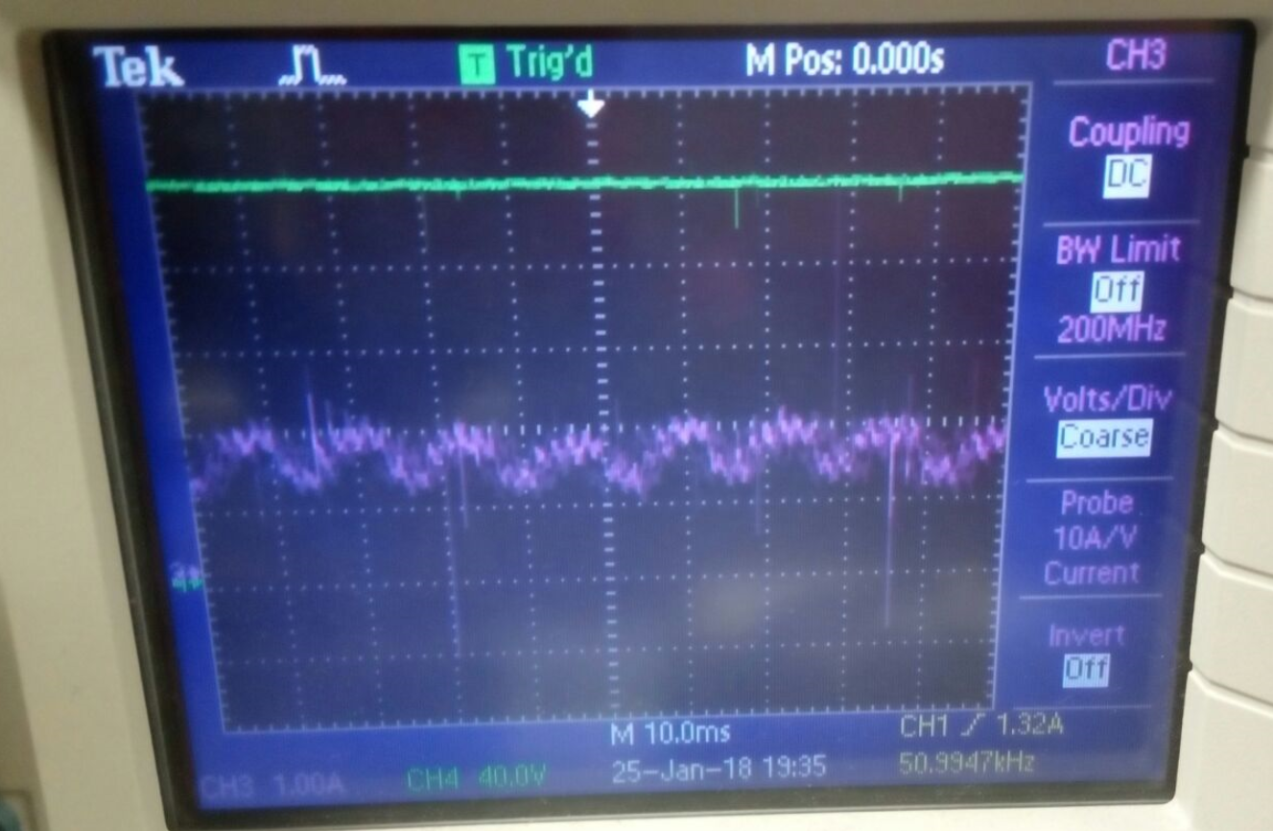

Figure 30: Output Voltage (Green Line) and Output Current (Purple Line) for Motor Load

As shown in Figure 30, output voltage is almost DC, and output ripple is between 1A and 2A under no load.

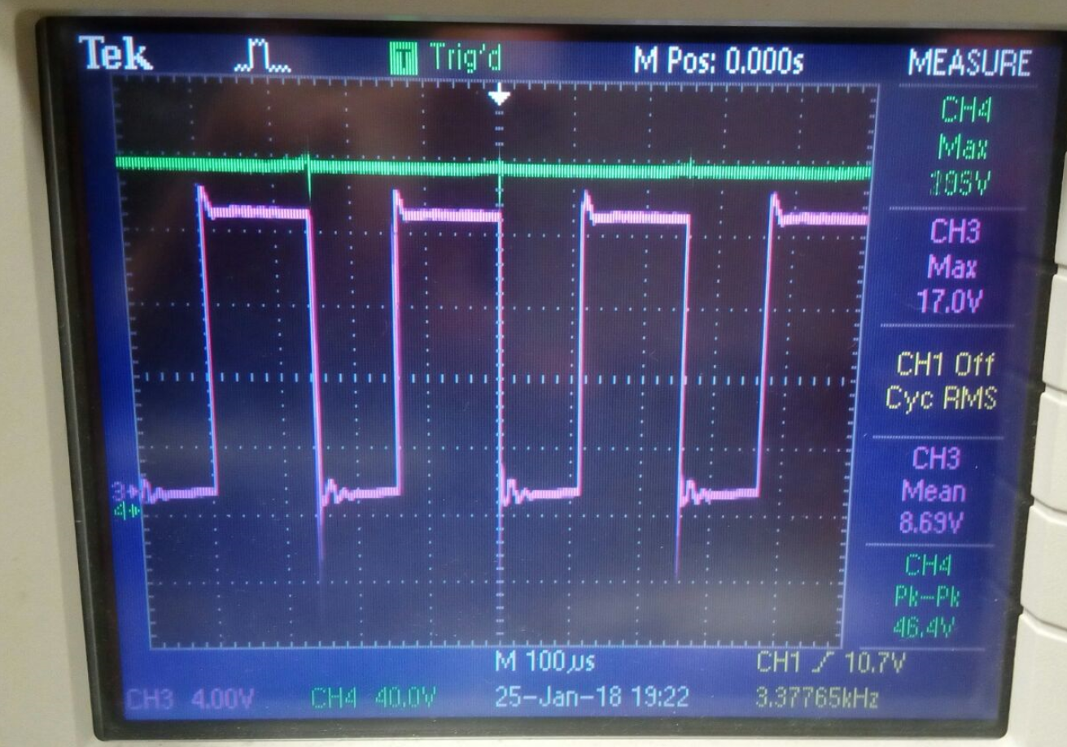

Figure 31: PWM from output of TLP250 and Output Voltage

As R load test, PWM is produced via TLP250 optocoupler and this PWM is sent to gate channel of the power MOSFET. When PWM is increased, motor speed also increases and vice versa.

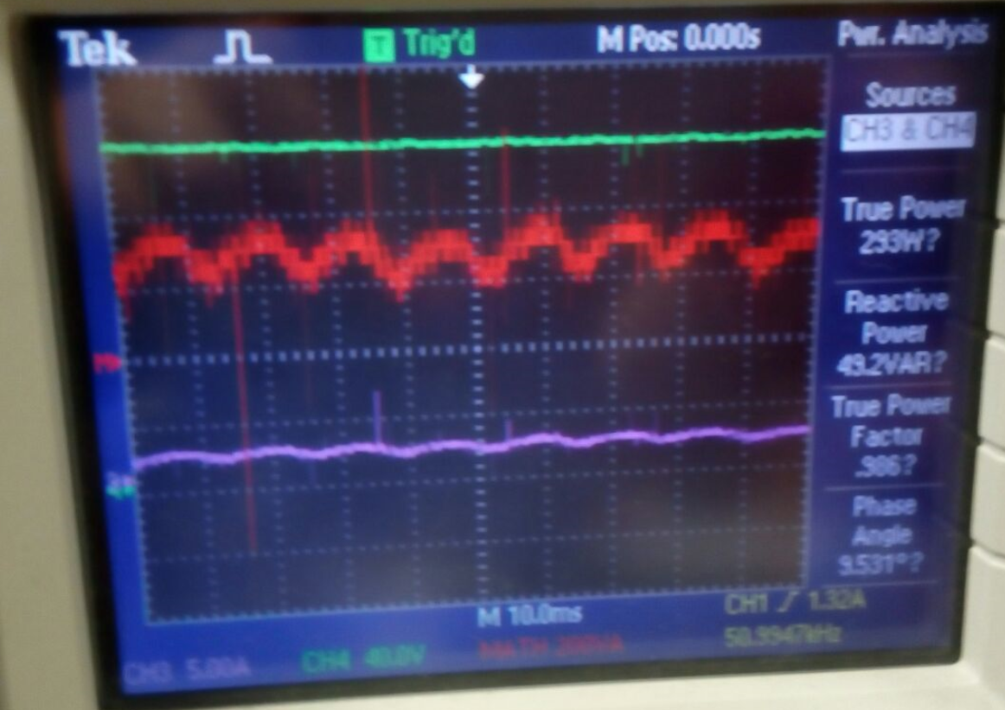

Figure 32: Output Power Analysis for Motor Load

Output power analysis is shown in Figure 32. When output voltage is 120 V, output power is 293 W.

Also, this motor driver is tested under load. When this setup works nearly 5 minutes under load, power MOSFET is nearly 115 0C as shown in Figure 33.

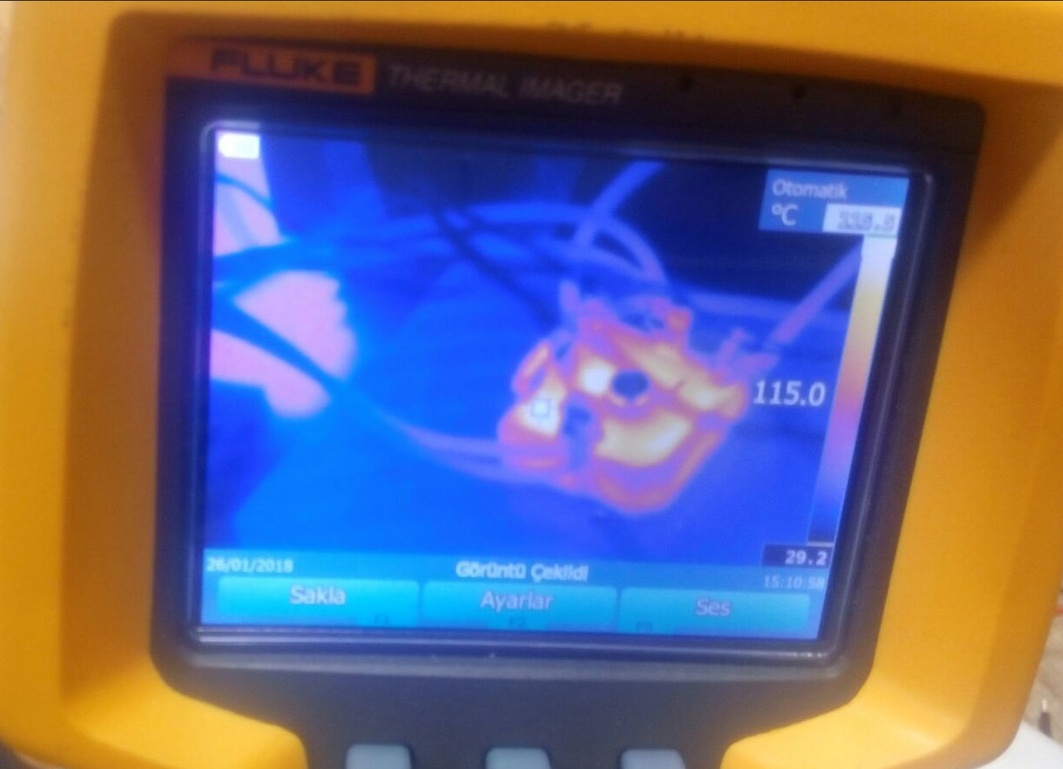

Figure 33: Temperature of Power MOSFET Under Load After Five Minutes

# CONCLUSION

In this project, controllable DC motor driver is implemented. In this process, appropriate topology is investigated, simulations are observed and components are selected for preferred topology which is three phase diode rectifier and buck converter. Gate driving of switching element is one of the most crucial point for a power electronic application. In this process, this fact is observed. If gate driving is paid insufficient attention, switching element may burst or burn. Also, current and voltage ratings should be taken into account. There are some difference between theoretical and experimental results, such as inductor voltage and continuous conduction mode boundary. In addition, when a motor is driven, start up current is the other crucial point. Components should be selected by taking into this starting current. Moreover, thermal analysis and cooling is the other crucial operation. Heat sinks should be selected carefully. When switching element is tried to cool with a small heat sink, some problems are observed for high currents. After that heat sink is enlarged.

In conclusion, importance of component selection and cooling operations are observed thanks to this project. Also, difficulties are experimented when implementing hardware circuit

# REFERENCES

[1] TLP 250 Datasheet: <https://toshiba.semicon-storage.com/info/docget.jsp?did=16821&prodName=TLP250>

[2] 3phase Diode Bridge Rectifier Datasheet: <https://www.rectron.com/public/product_datasheets/skbpc3504-skbpc3516.pdf>

[3] MOSFET datasheet: <http://www.vishay.com/docs/91237/91237.pdf>

[4] Freewheeling Diode Datasheet: <http://ixapps.ixys.com/datasheet/dsep30-06a.pdf>

[5] http://application-notes.digchip.com/070/70-41484.pdf